**Customer Home Page**

The customer home page consist of sliding images with animated text, parallax effect, hair style trends images and a footer that tells the salons contact information and location that used google map API.

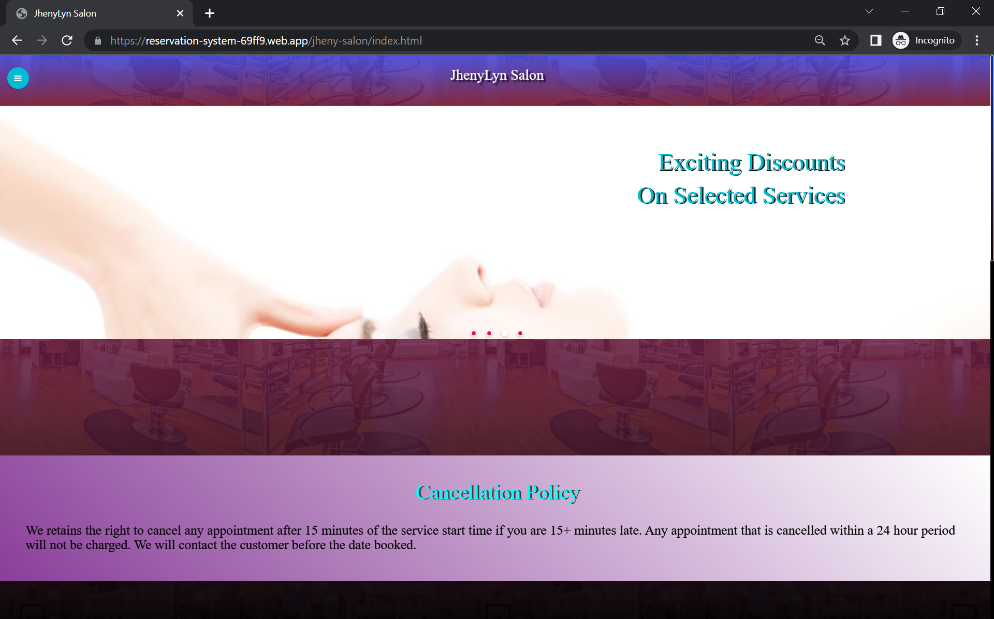

*Figure 22. Generate IP Address to the user*

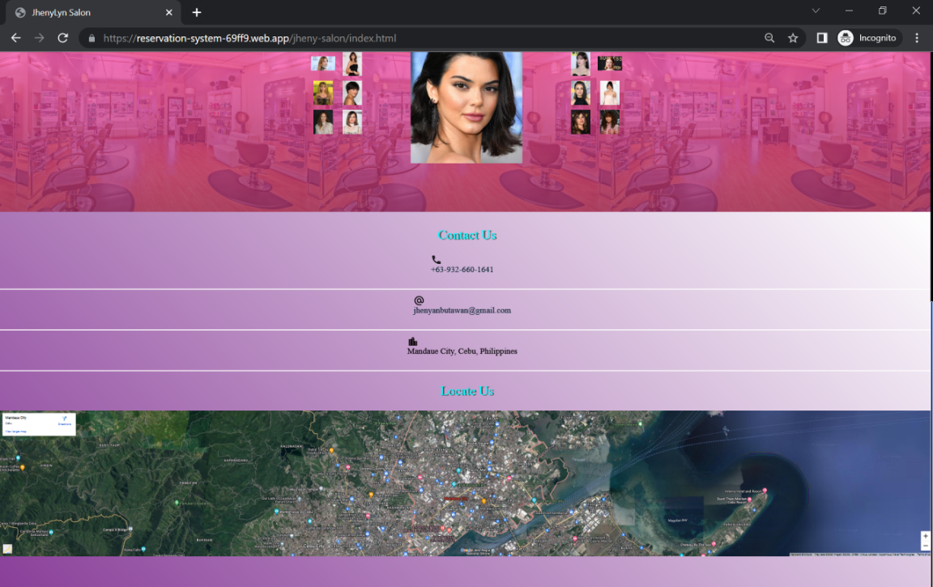

*Figure 22. Generate IP Address to the user*

**Customer Booking Page**

The customer booking page consist of services with its category and service name, price, discounts information that let customers select the services offered. The sum total of the selected services is calculated automatically. The customer cannot send the request without filling all the required fields and not selecting any services. Customer cannot check the time availability without selecting the desired booking date. The submit button should be click once the required information has been filled. There should be a message that will display in every successful entry. If the user encountered unstable or lost the internet connection the data will not be sent but the system will stored the activity information of the user, when the internet is back online then the user can send the request. The system has been designed to let customer still recover the information as far as internet connectivity is concerned.

**Send Booking Request**

1. Click the sidebar button.

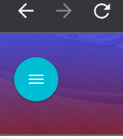

*Figure 22. Customer user menu button*

1. Select the “Booking” text.

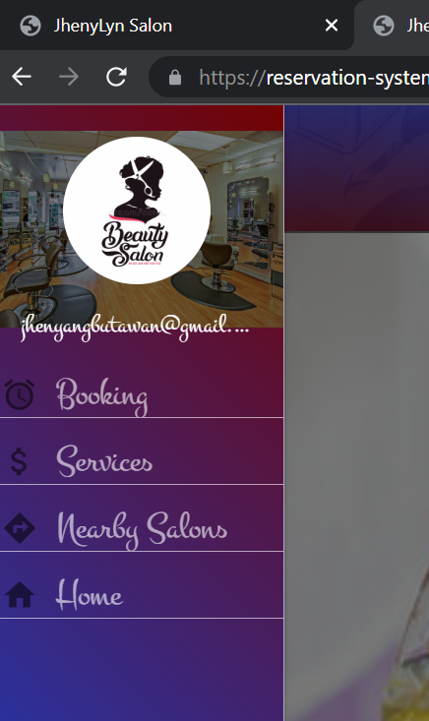

*Figure 22. Customer user sidebar menu with booking text*

1. Check desired services.

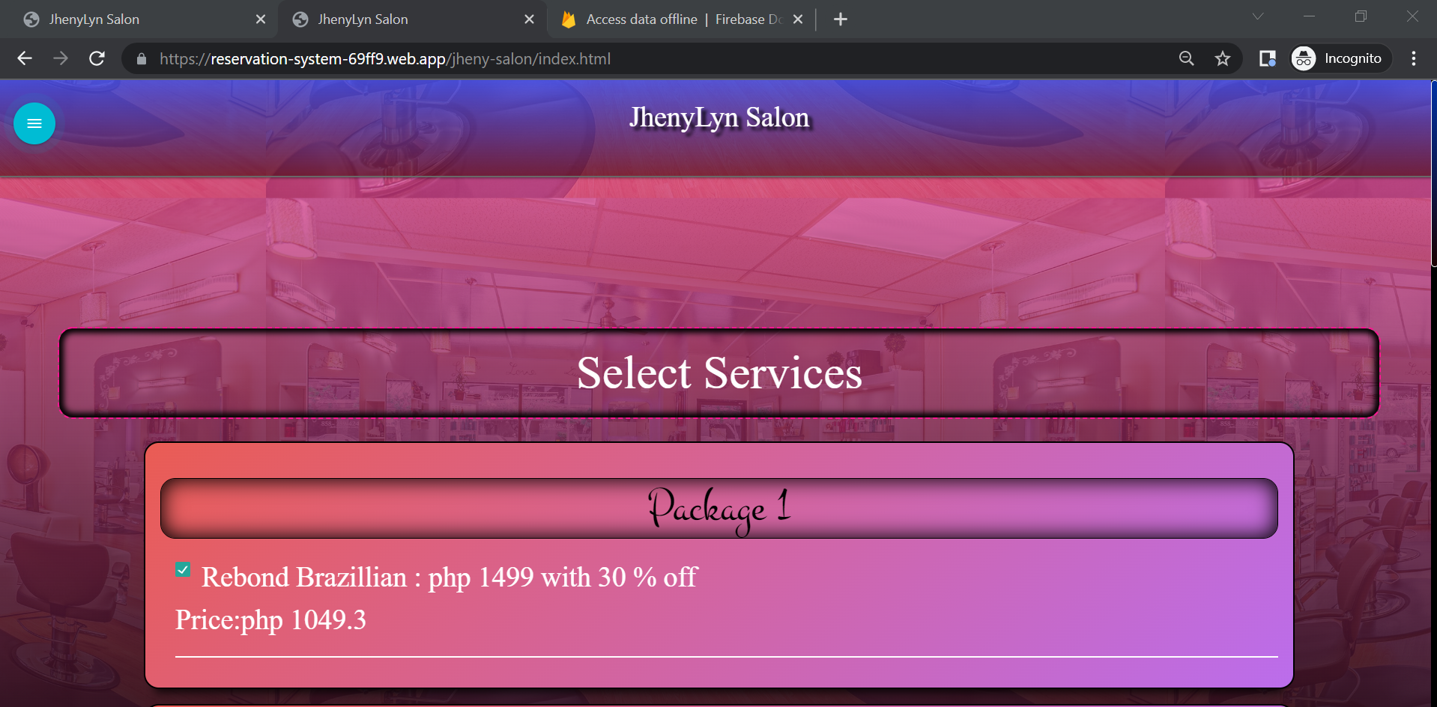

*Figure 22. Customer user services*

1. Enter customer name and contact information.

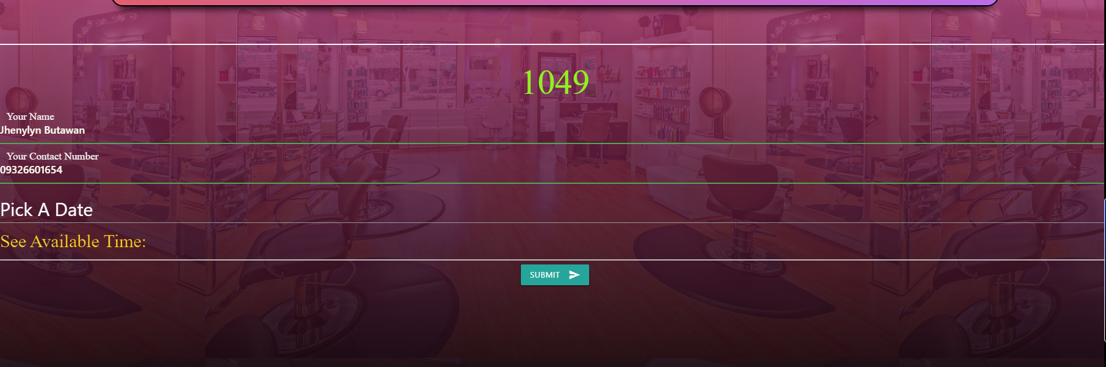

*Figure 22. Customer username and contact number*

1. Click the “Pick A Date” to select a date.

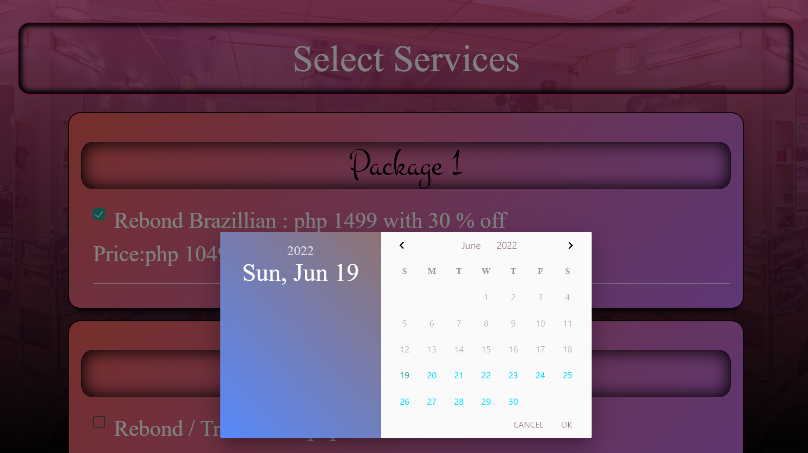

*Figure 22. Customer user pick a date*

1. Click the “See Available Time” to check time availability.

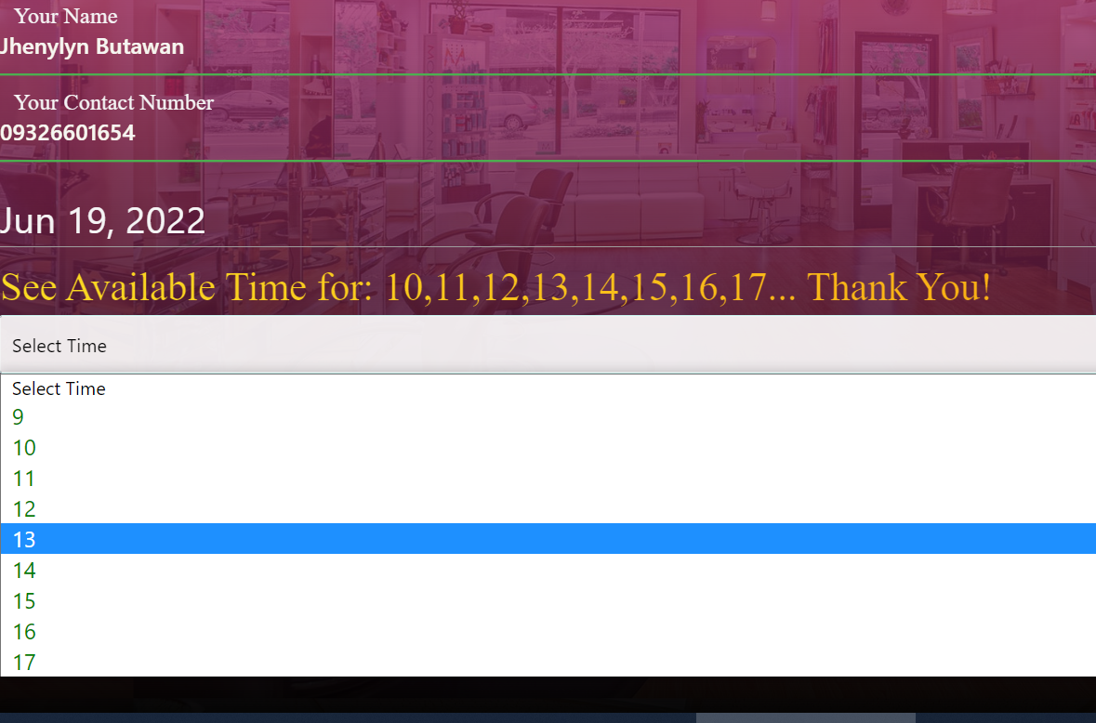

*Figure 22. Customer user time selection*

1. Once the required fields has been filled then click the submit button to send the request.

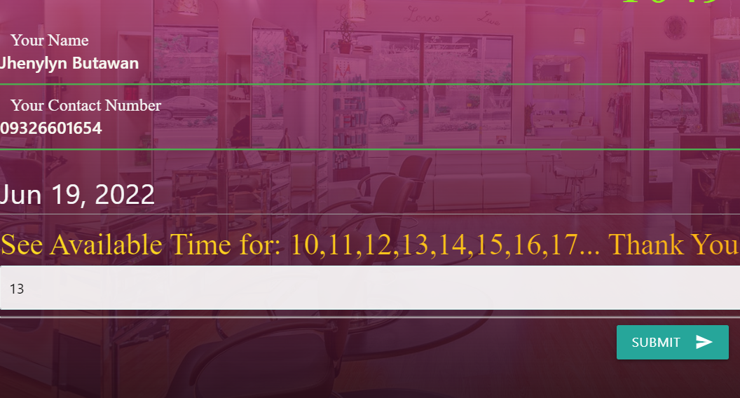

*Figure 22.Customer user submit booking request*

1. Click the “Book Another Appointment” to transact another booking.

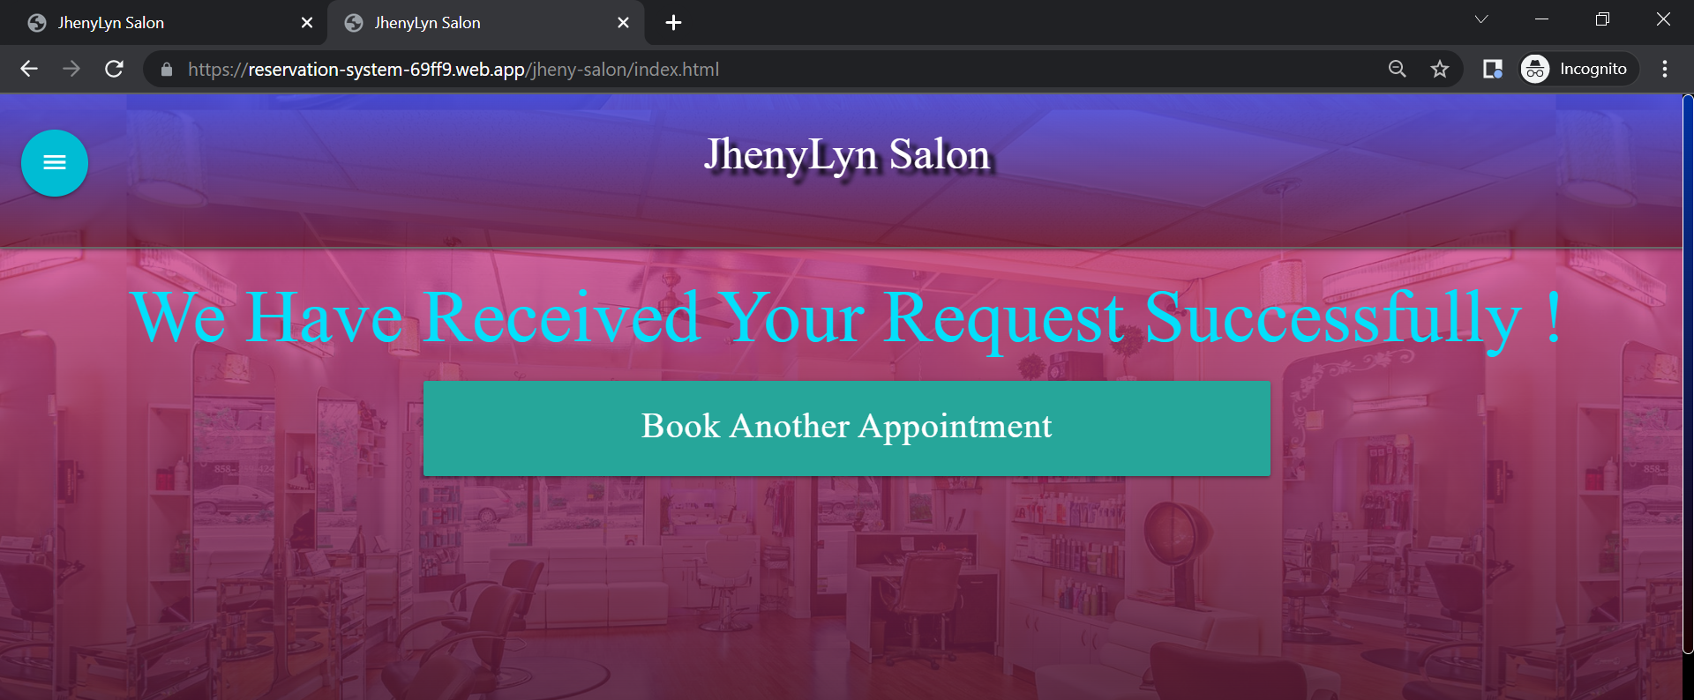

*Figure 22. Customer user book another appointment*

**Services**

The Salon services are all visible to the customer.

1. Click the sidebar button.



*Figure 22. Customer user sidebar menu button*

1. Select the “Booking” text.



*Figure 22. Customer user sidebar menu*

1. View services

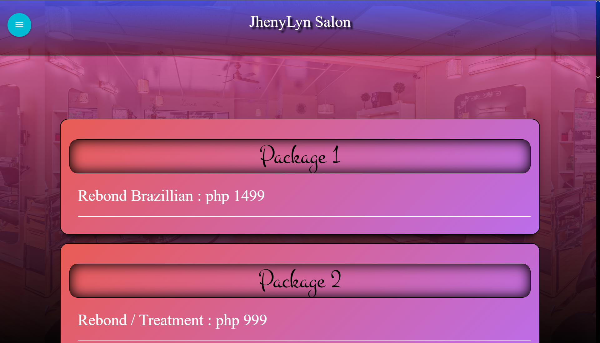

*Figure 22. Customer user services*

**Nearby Salon**

Select the “Nearby Salon” from the sidebar menu , once clicked then it should redirect the user to the nearby salon page.

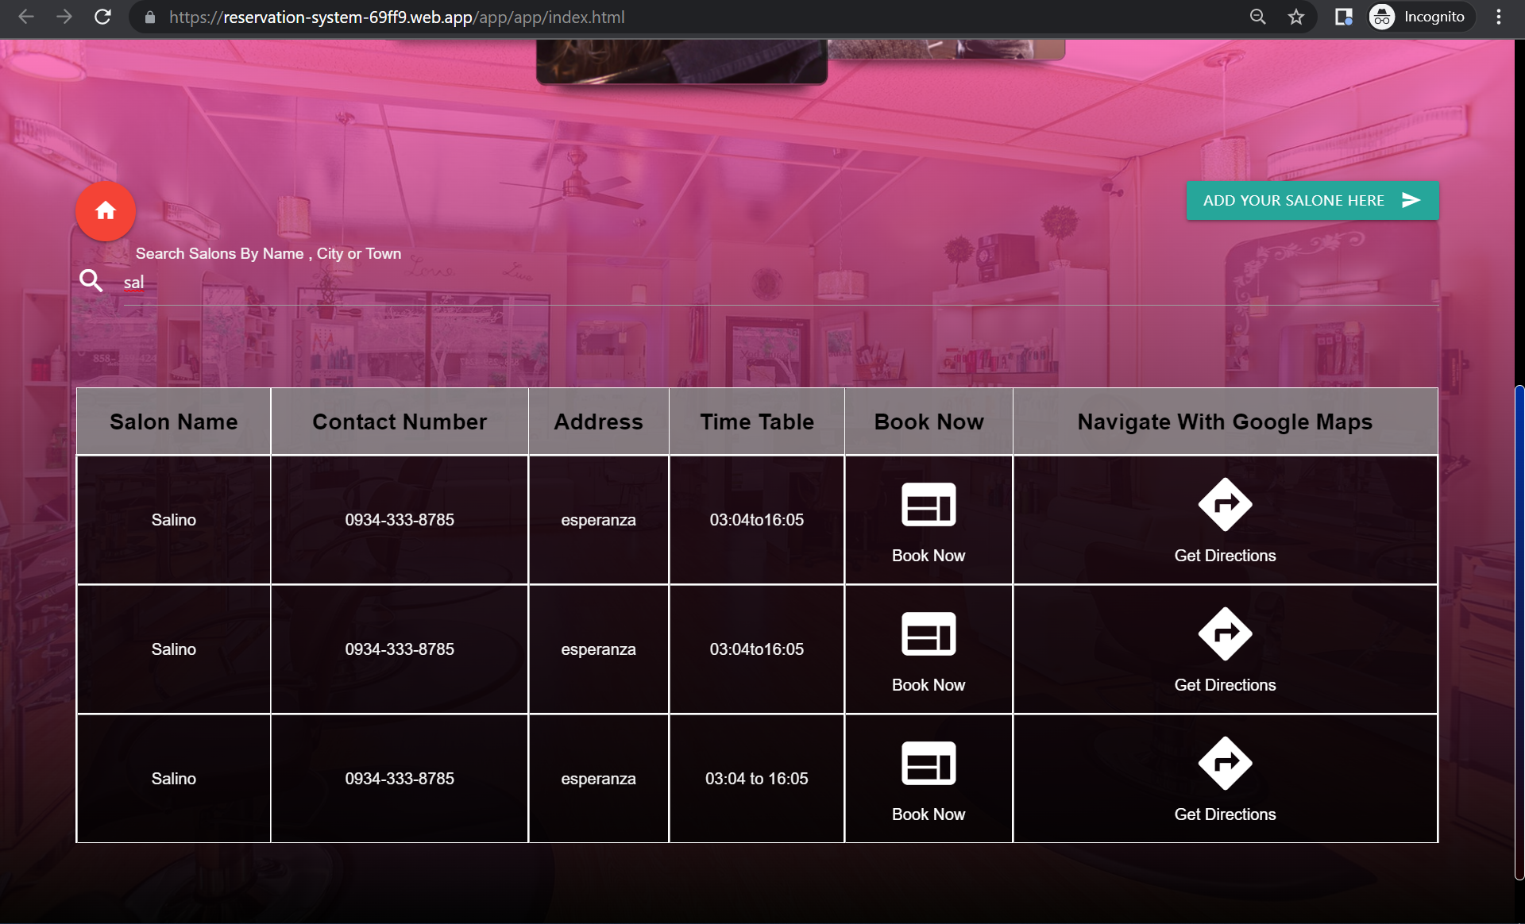

*Figure 22. Customer user find nearby salon*

Only registered salon will be displayed if the salon is not existing from the list then the user should send a request to include their salon business on this feature. To do that the user can click the button “ADD YOUR SALON HERE”. The user should click the submit button as per image shown below.

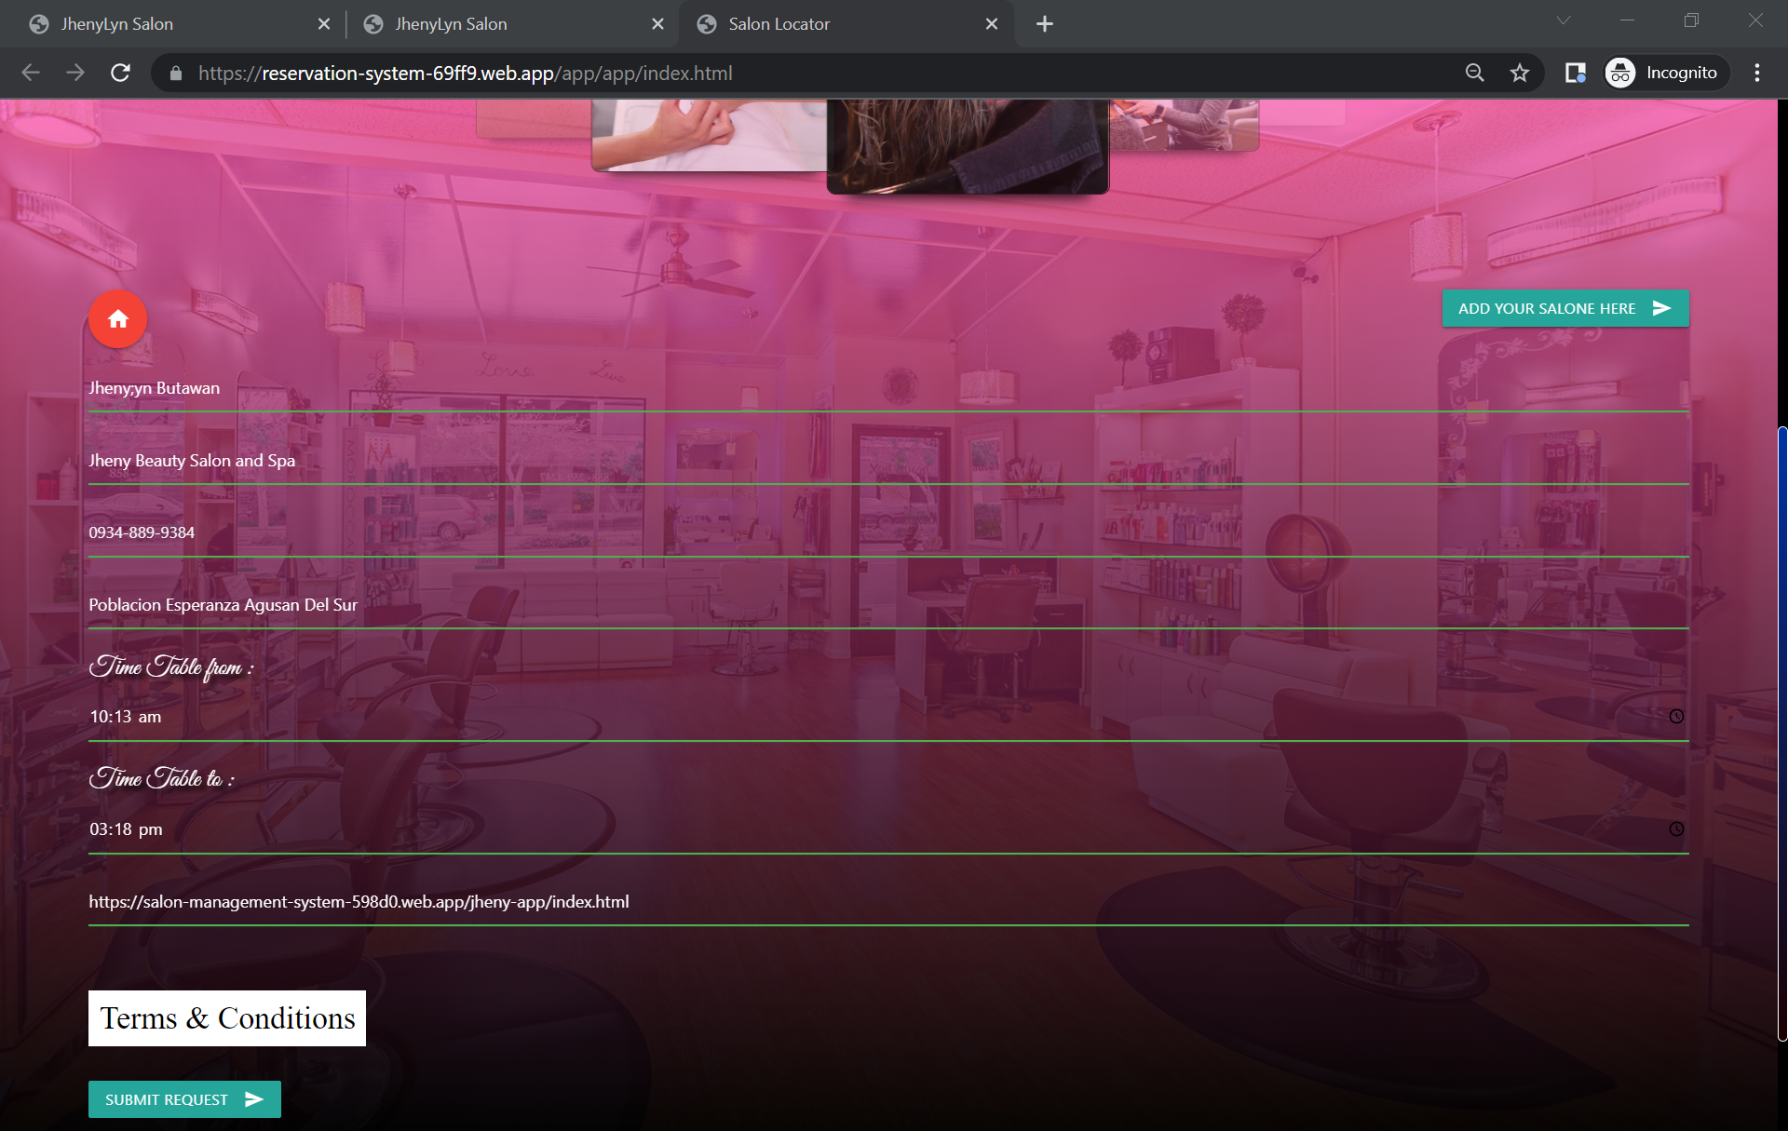

*Figure 22. Customer user register salon*

The user can go back to home page via clicking upon the red button shown in the picture above.

**Admin User Page**

The admin side of the salon booking and management system application has the control of all incoming booking request, staff , services and updating the statuses of the requests. It has a drag and drop of staff cards to determine the staff availability throughout the entire activity inside the salon. To start the entire salon managerial feature. The admin user should add the salon services.

**Login**

The admin user must enter the valid login credentials.

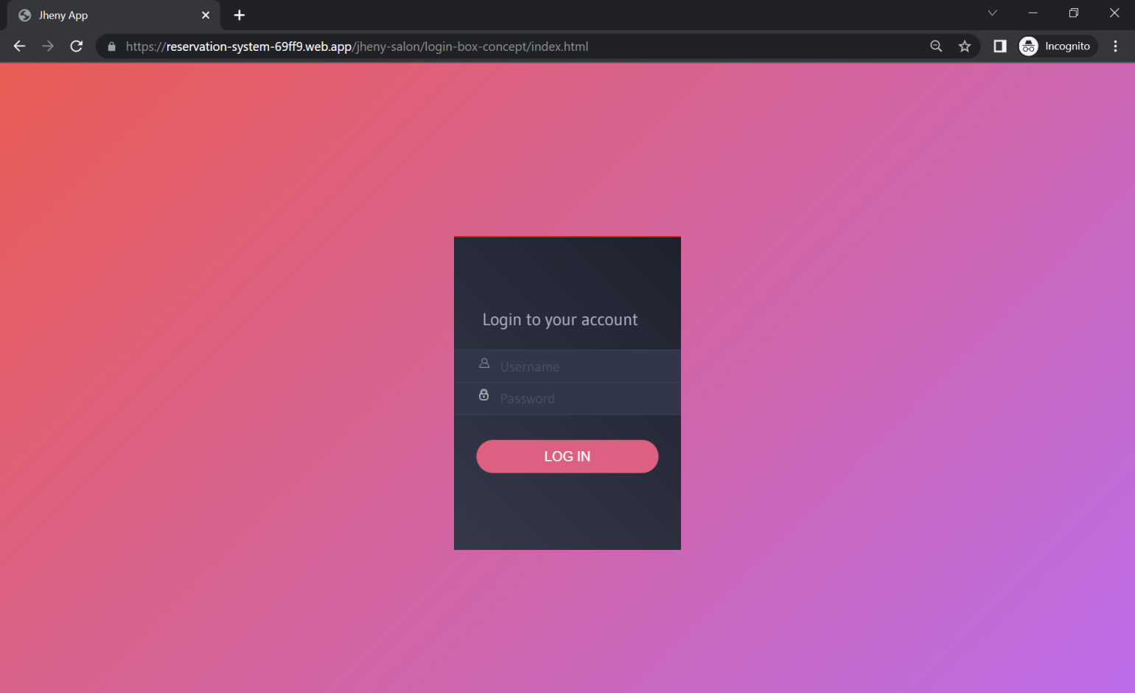

*Figure 22. Admin user login*

**Services**

1. Select the “Services” option on the sidebar menu

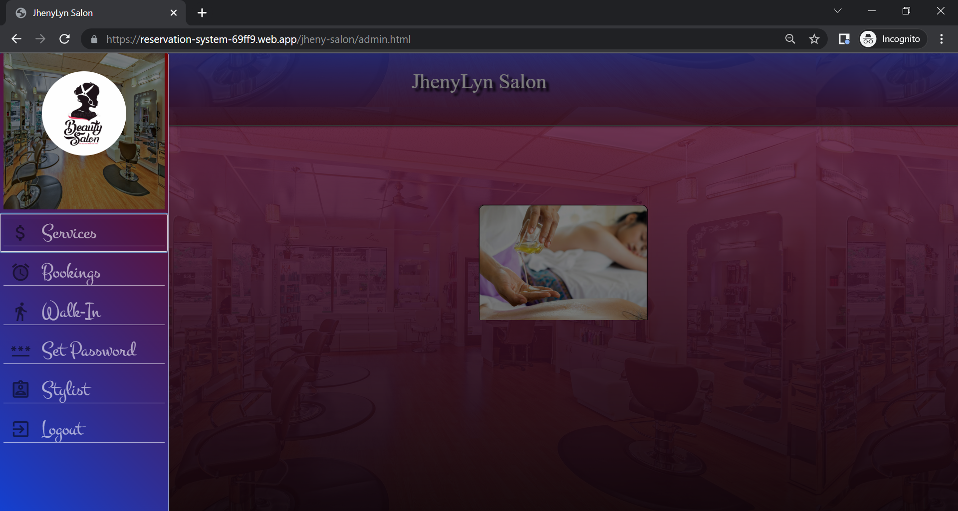

*Figure 22. Admin user navigate services*

1. After selecting the “Services” option. It should redirect to the services page to manage its data. The user must click the “Add Service”button to display all fields that is required.

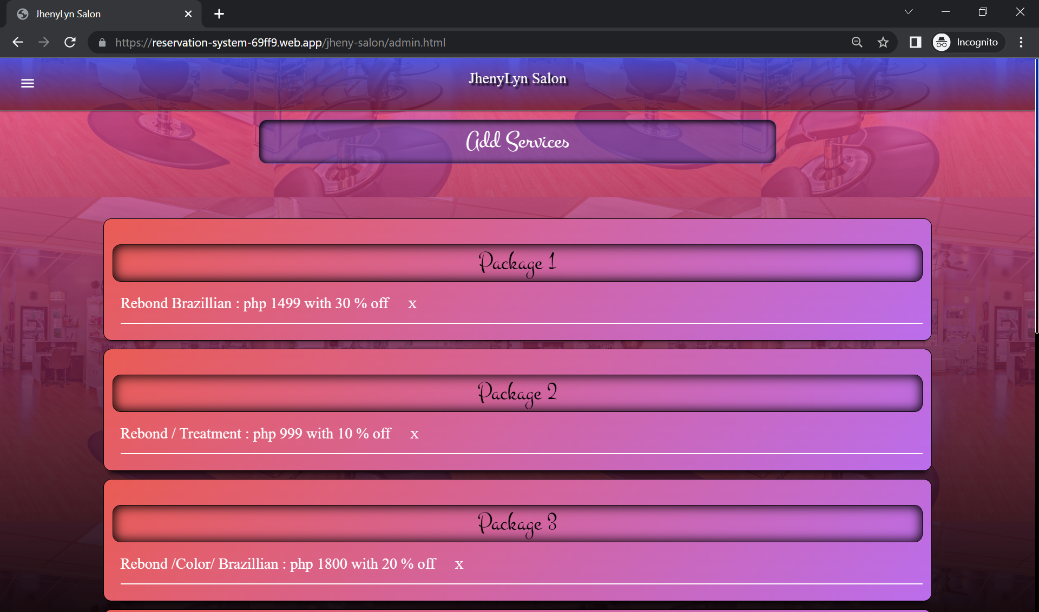

*Figure 22. Admin user add services*

1. Once added the data will be shown as per image below.

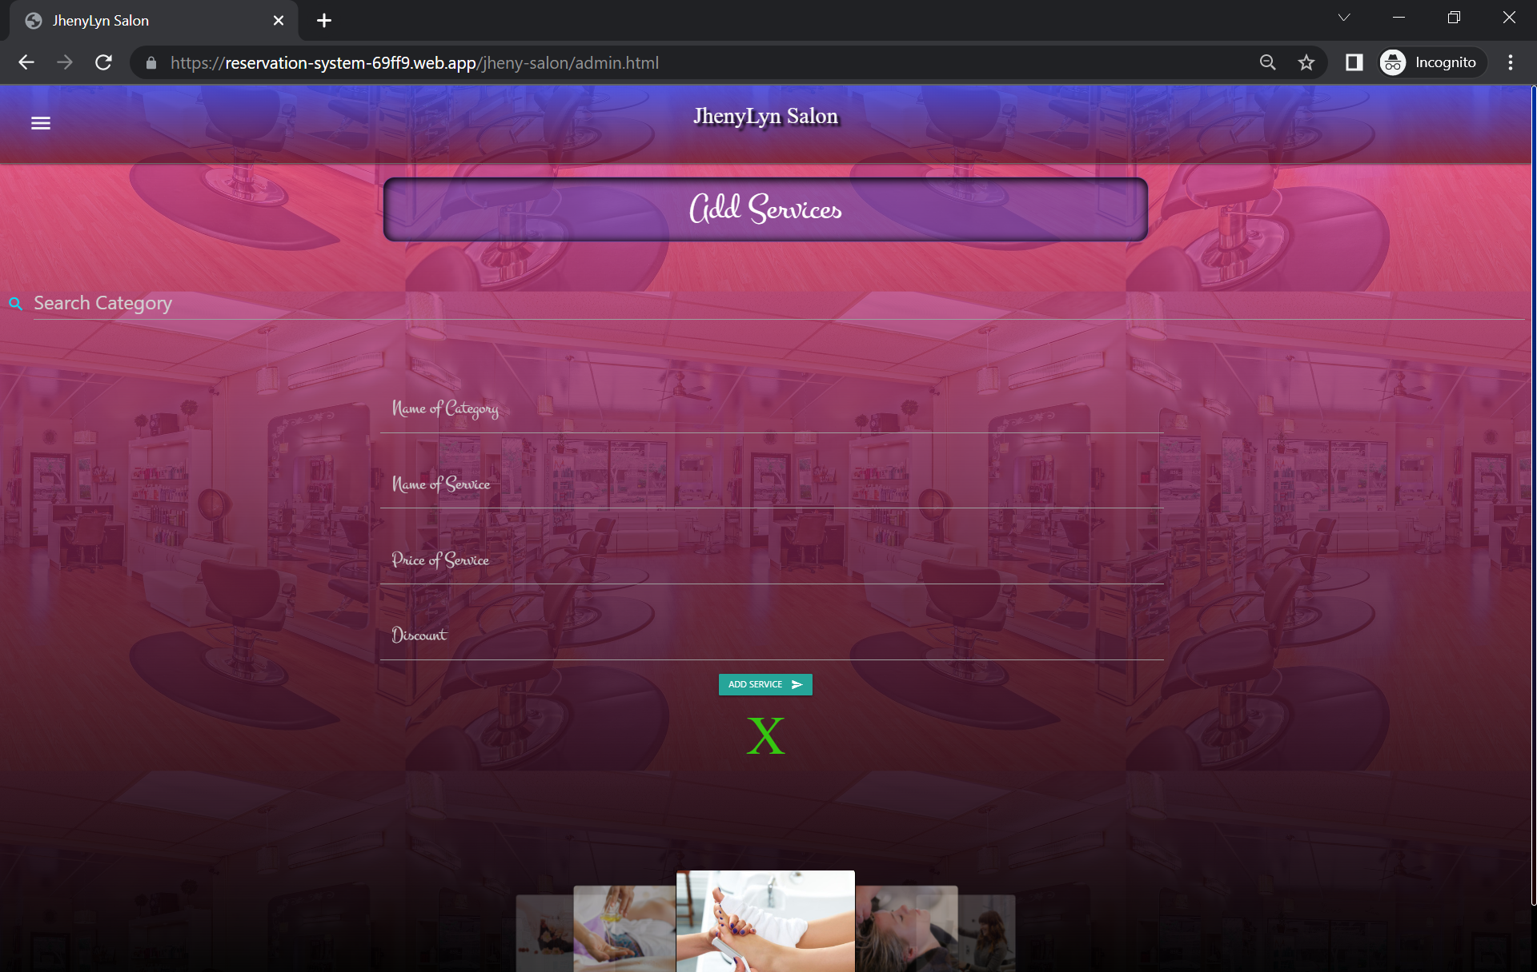

*Figure 22. Admin user view services*

1. The admin user can edit the data of the services via clicking the card, it will enable the edit capability. The edit button must be click to send the updated data. The “X” button corresponds the delete functionality.

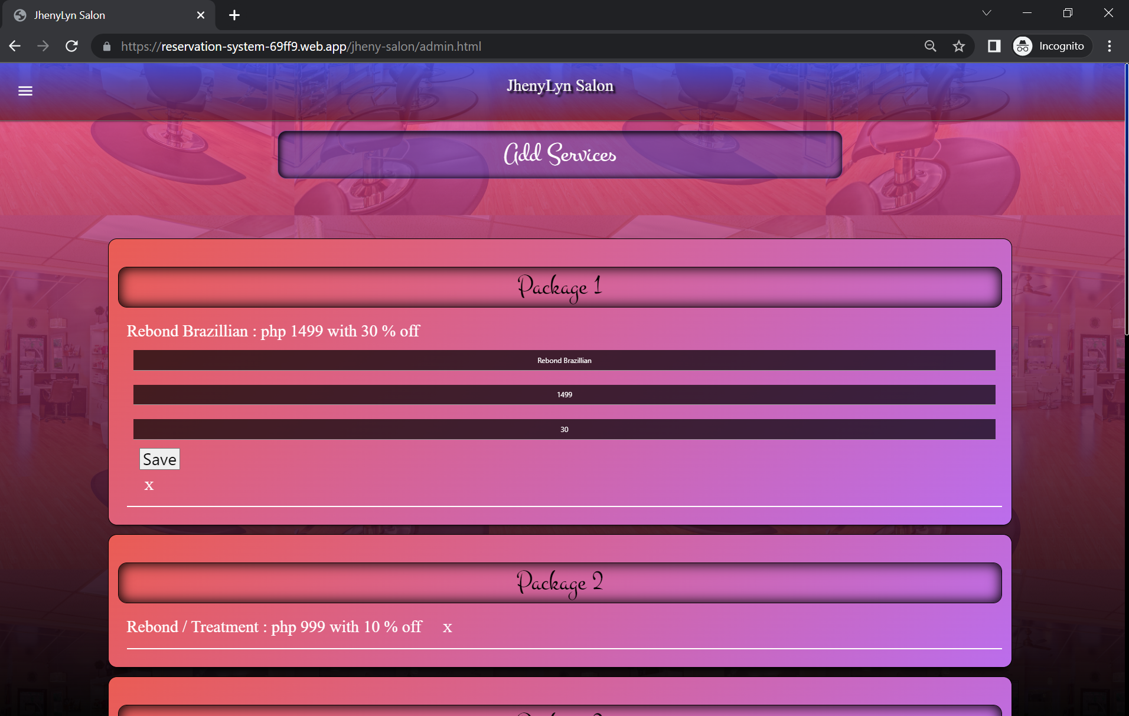

*Figure 22. Admin user edit services*

**Booking**

To check booking request the user must navigate to booking section.

Once the customer successfully sent the request , the pending request will show up on admin side.

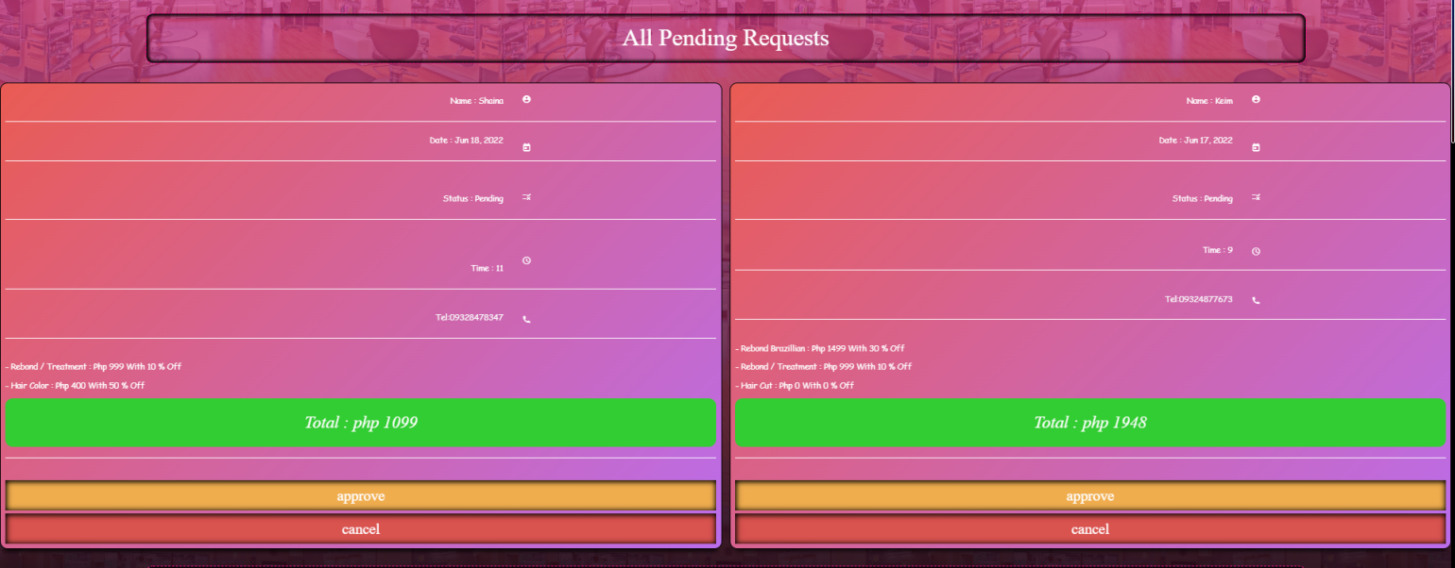

*Figure 22. customer pending request*

If the customer will show to the salon then admin can approve his/ her booking.

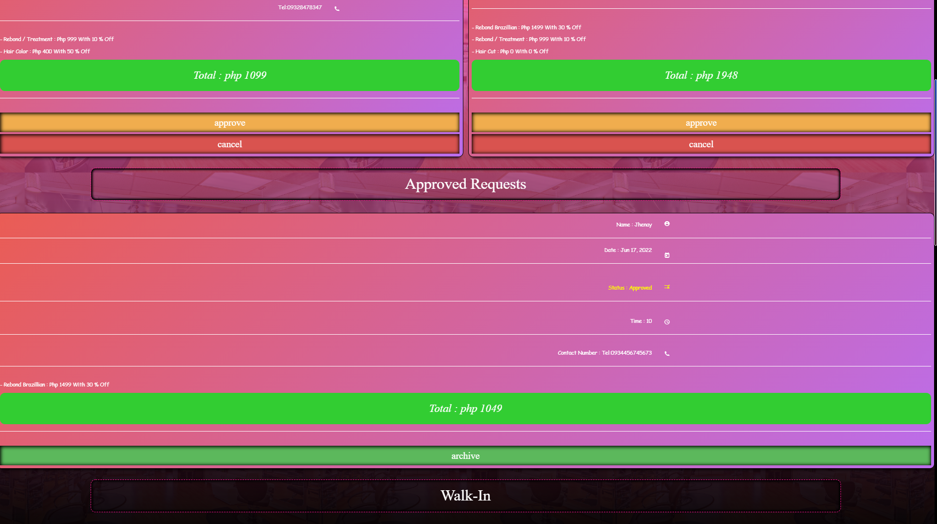

*Figure 22. customer approved request*

The data of the walk-in customer.

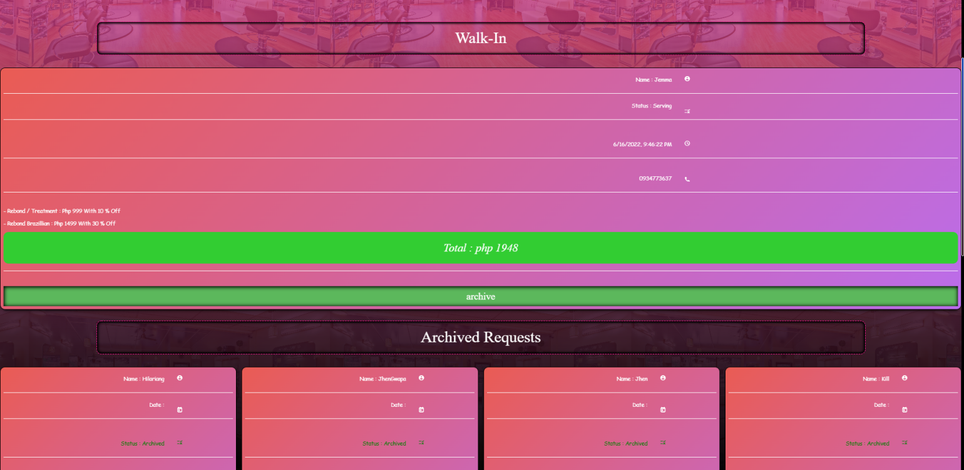

*Figure 22. Customer Walk-In request*

The approved and walk-in’s data can be archived.

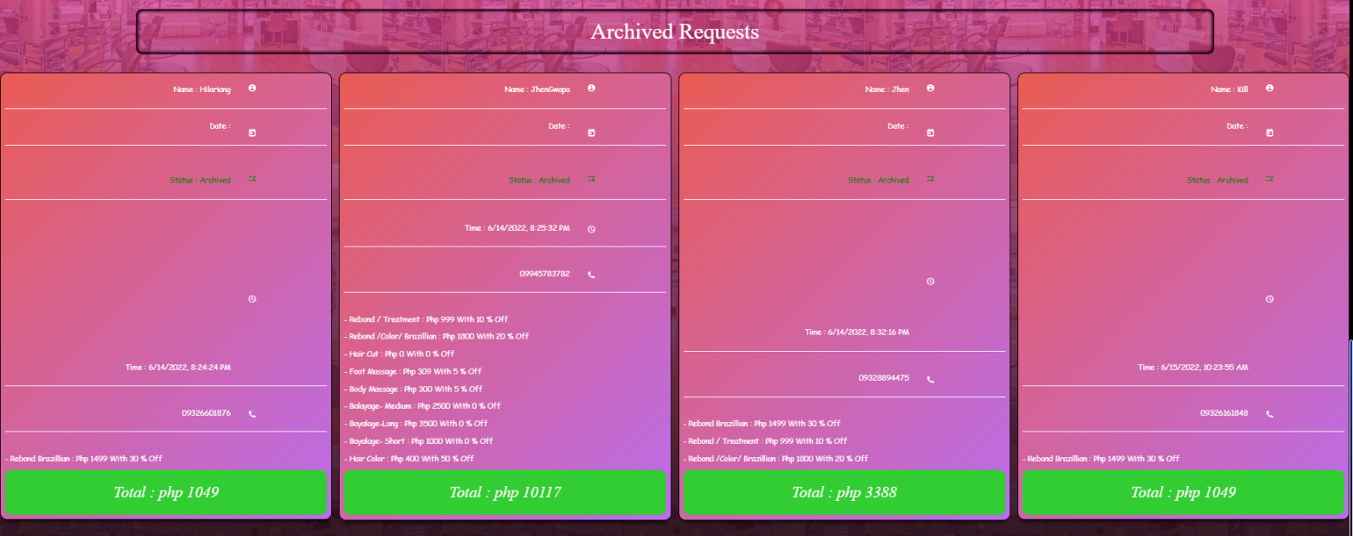

*Figure 22. Customer Archived data*

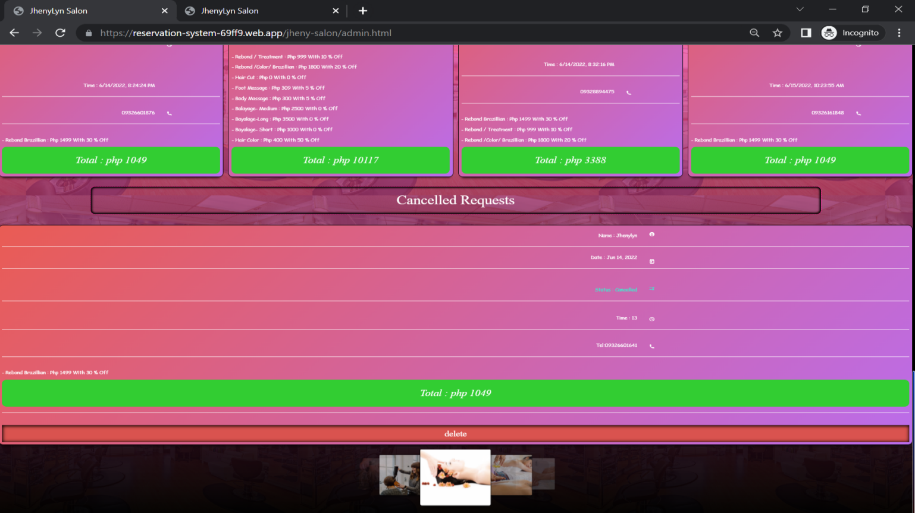The pending requests can be canceled.

*Figure 22. Customer canceled request*

**Walk-In**

The data of the walk-in customer should be filled on the walk-in side. The admin user must select the desired services. The required fields are the customer name and contact information after filling the fields the request is ready to send via clicking the submit button. The date and time of transaction will automatically recorded.

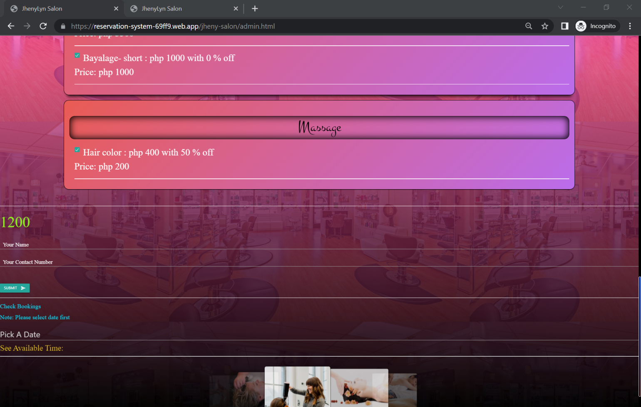

*Figure 22. Walk-In transaction*

**Stylist**

To add stylist the user must navigate to stylist section. The user can add, edit, delete staff data and can drag and drop cards to determine the staff time availability.

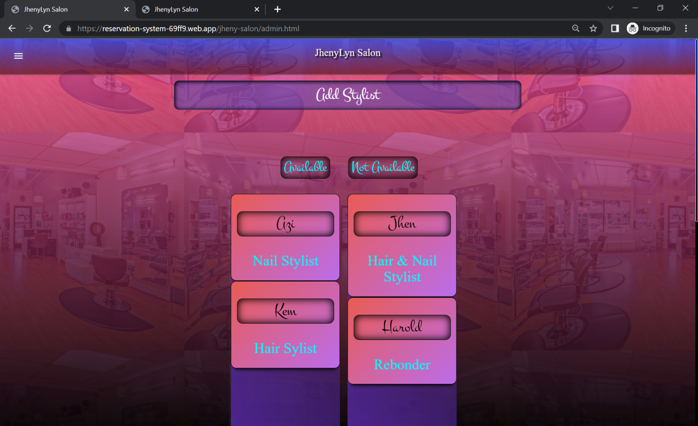

*Figure 22. Stylist Availability*

The admin can edit and delete stylist data.

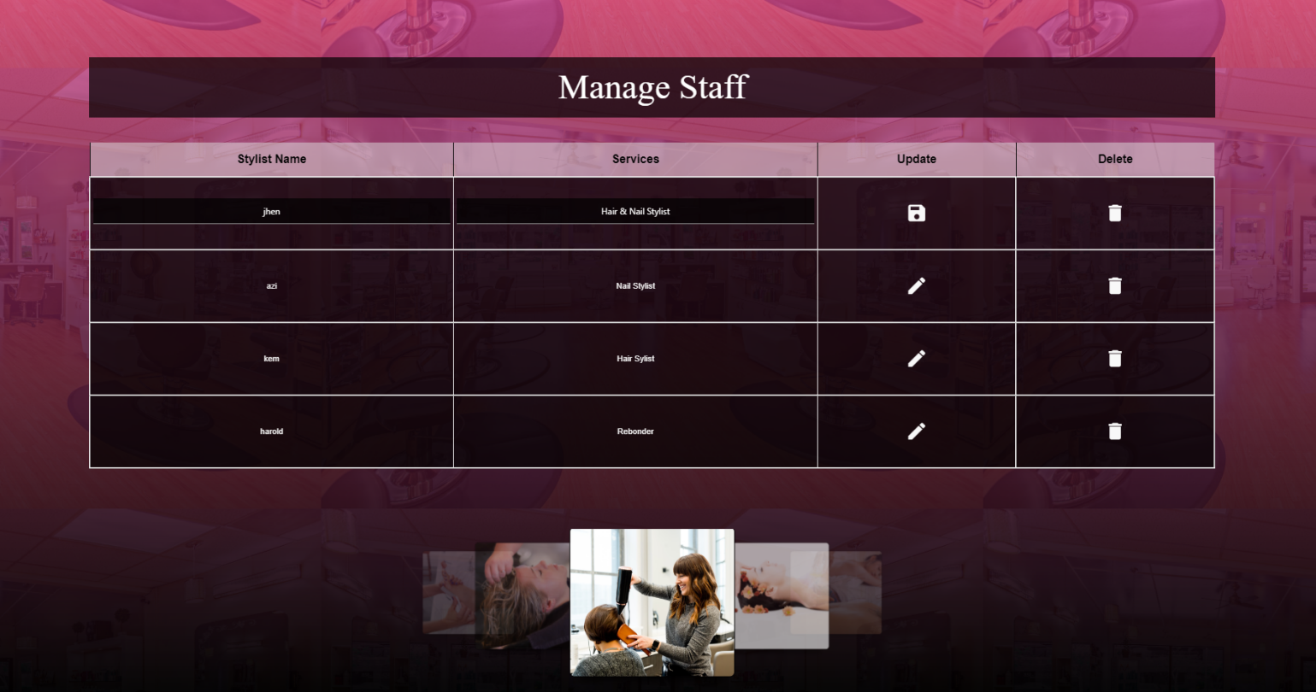

*Figure 22. Manage staff/stylist*

**Set Password**

Admin is required to change password. To set password the admin should navigate to set password.

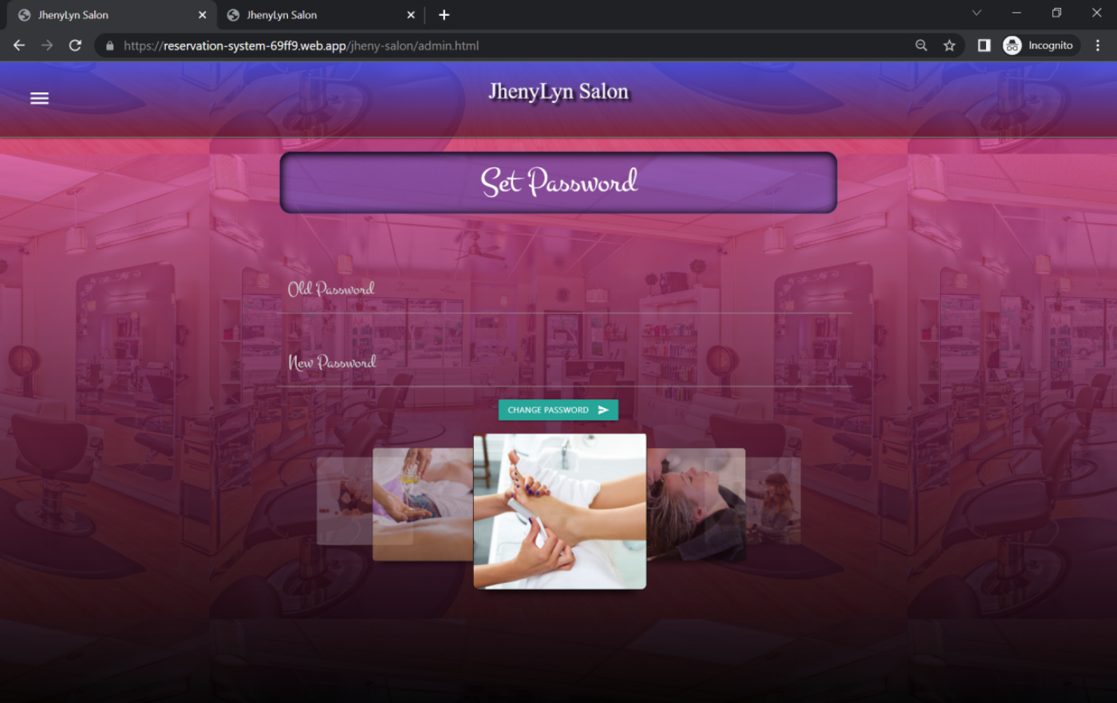

*Figure 22. Admin set password*

**Logout**

To logout the admin user must click the logout option on the sidebar menu. The admin will be prompted to logout the system.

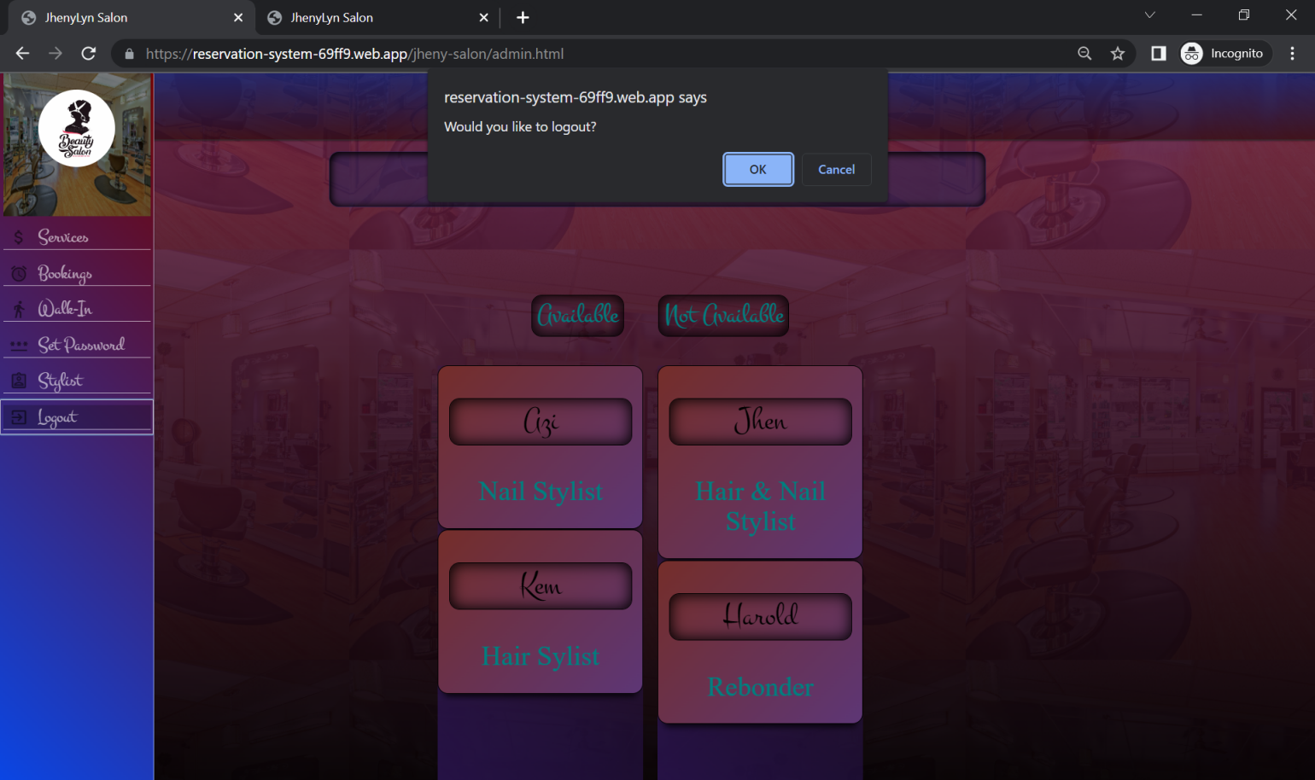

*Figure 22. Admin user logout*

**Super Admin**

The super admin has the capability to edit , delete and activate salons.

The Super Admin / Developer side login page.

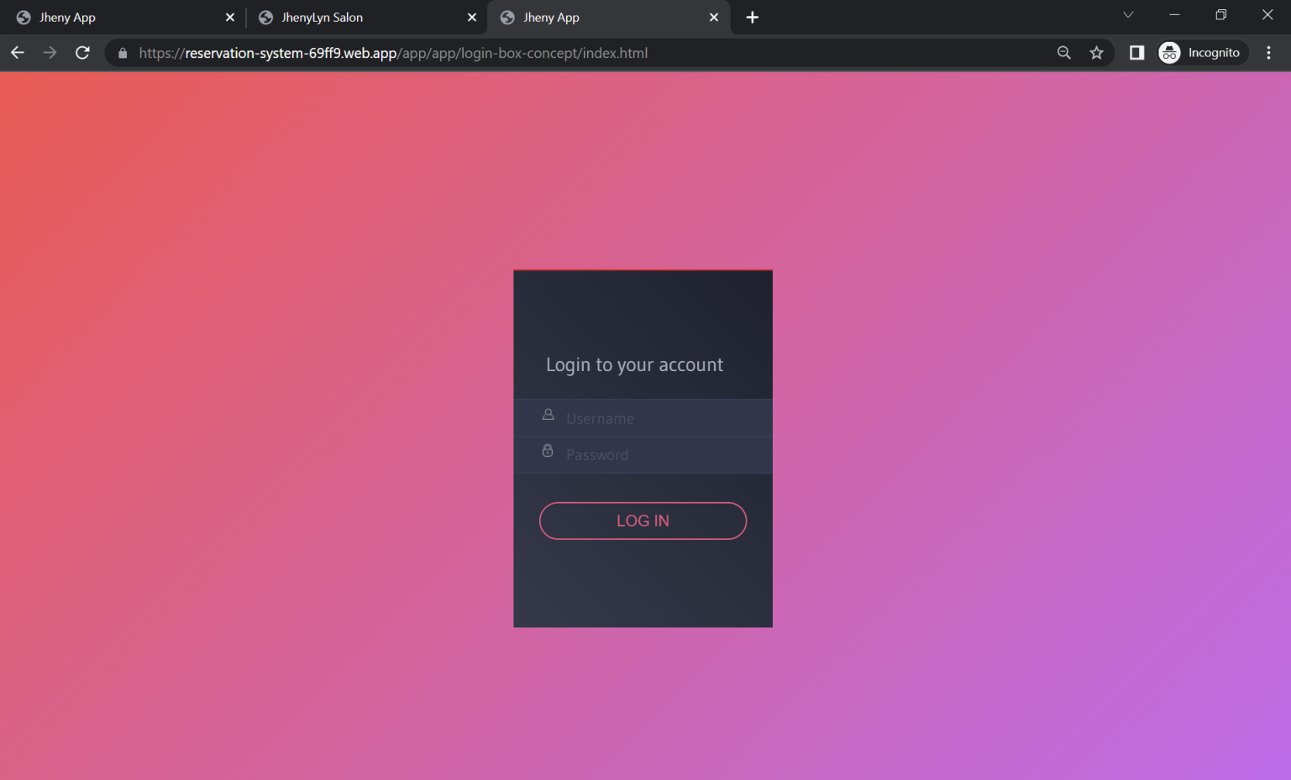

*Figure 22. Super admin login*

The pending request has approve, edit and delete functionality.

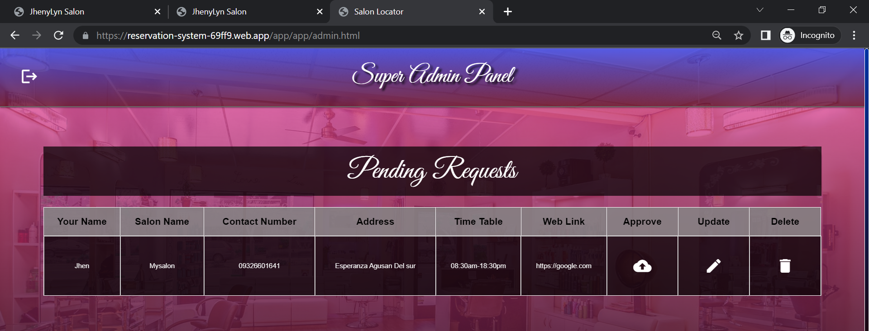To approve salon is to simply click the approve button. To edit is to simply click the edit button or click the column of the table. To delete is to simply click the delete button.There is always a prompt message in every action made

*Figure 22. Super admin Pending Request*

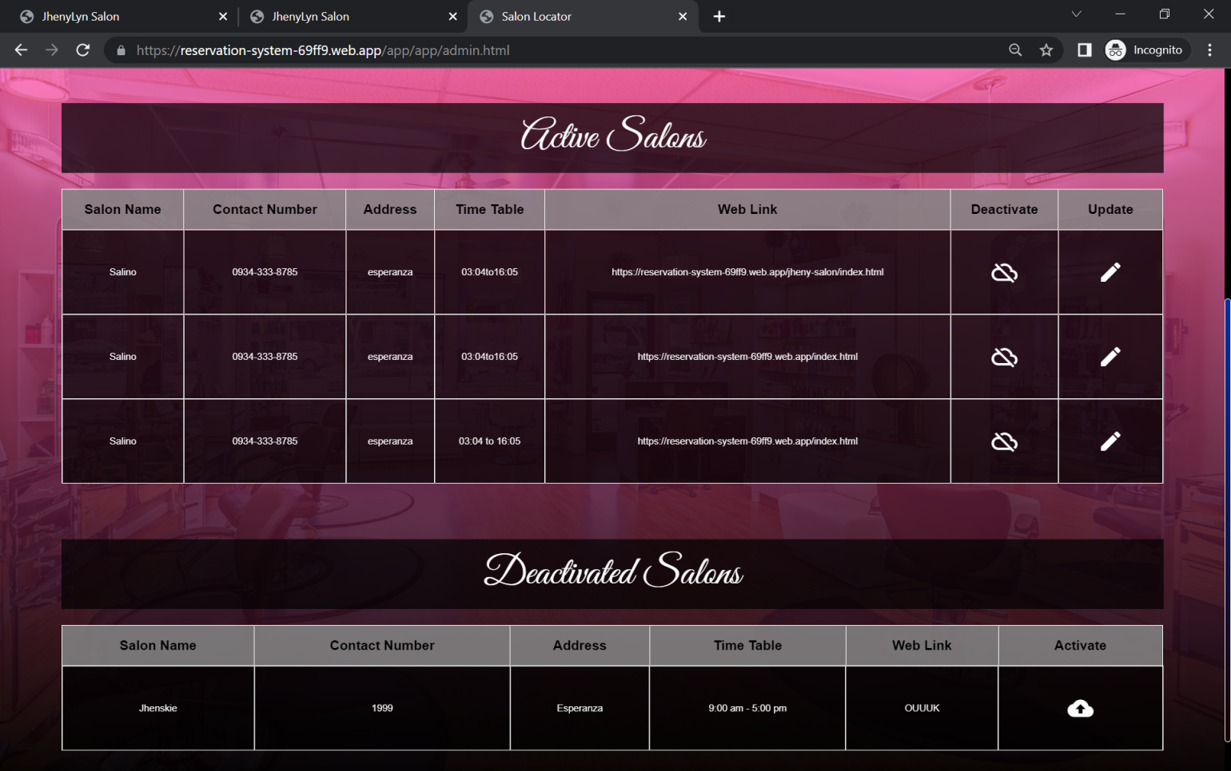

*Figure 22. Super admin Activate and Deactivate Salons*

To logout is to simply click the left upper side button. The developer will be prompted to logout or not.

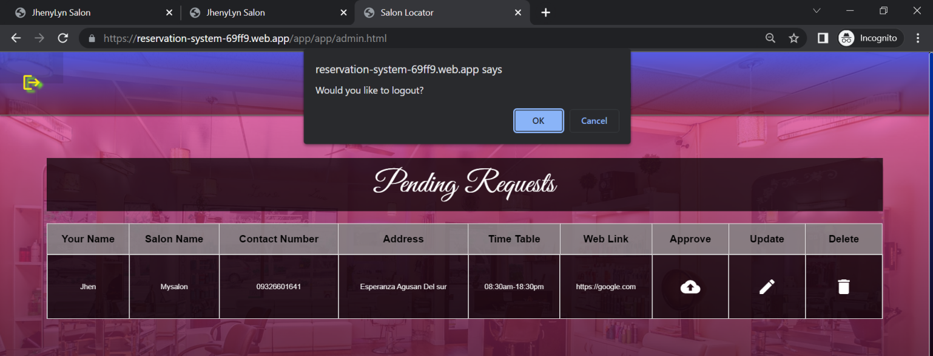

*Figure 22. Super admin Logout*